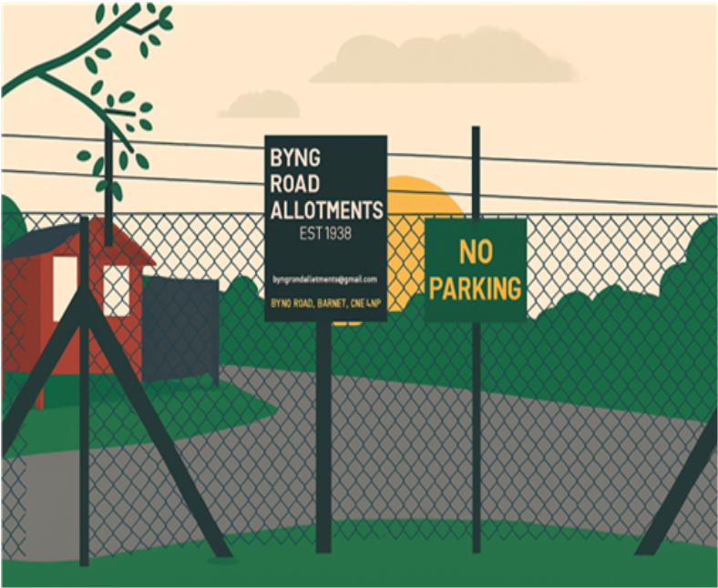
 | BYNG  ROAD  ALLOTMENTS  GROUP

HANDBOOK
2026
There have been allotments on Byng Road since 1939. We began as one of the first wartime allotments in the adjacent field, where Noah’s Ark and the Environment Centre are currently located. In 1947 we became a permanent allotment and in 1952 our allotment moved to its current location at the bottom of Byng Road.

In 2013 we entered a lease agreement with the London Borough of Barnet for 38 years, commencing 5 July 2013.

We occupy just over 3.5 acres and have over 90 plots of either 5-pole and 2.5-pole plots. A pole is an imperial measurement still used to define allotment areas because it appears in all the Allotment Acts from 1908 to 1950 and forms part of our Tenancy Agreement. The term pole is used to describe both length and area, originating from imperial measurement systems:

5 metres | = | 1 pole (length)
25m² | = | 1 pole (area)
5.5 yards | = | 1 rod, pole or perch
22 yards | = | 1 chain
30.25 yards² | = | 1 rod, pole or perch
4 poles | = | 1 chain
40 poles | = | 1 furlong

Our facilities include water supply, a communal plot with an apple orchard, a small wildlife plot, three on-site car parks and a chemical toilet during the spring and summer months.

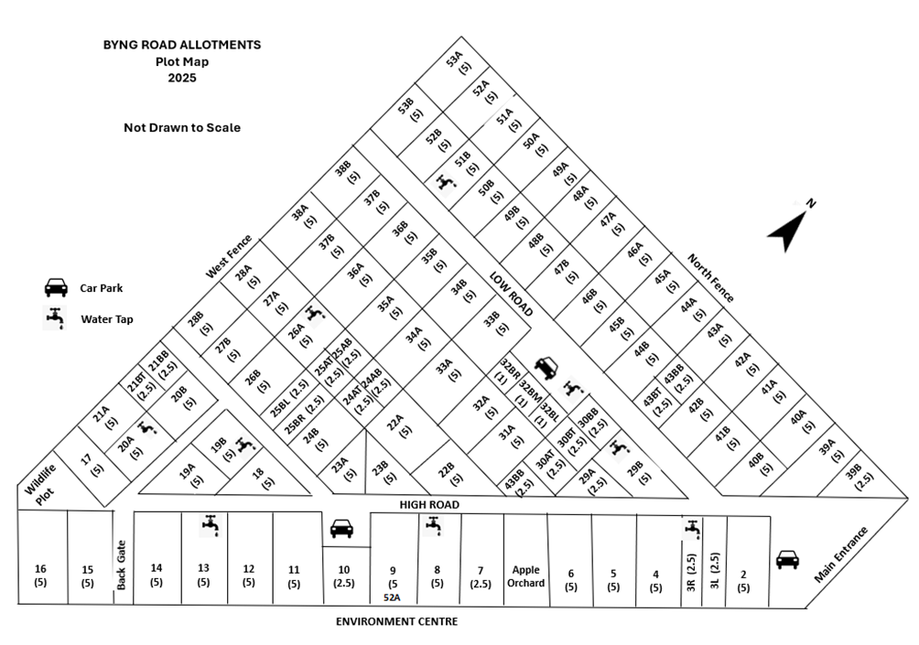

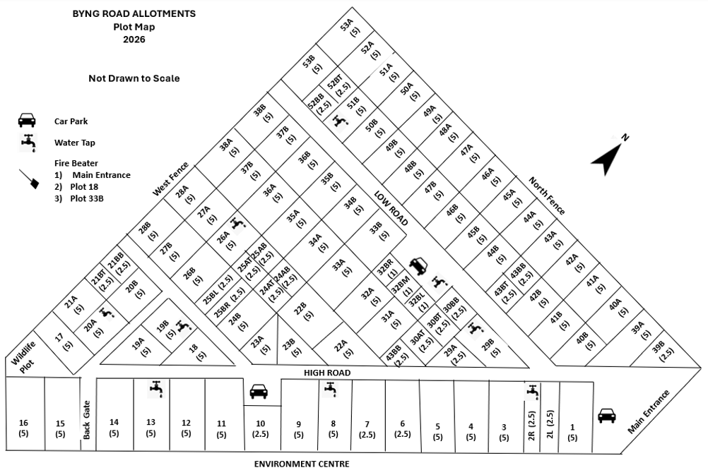

 | BYNG  ROAD  ALLOTMENTS  GROUP | TERMS AND CONDITIONS

A. INTERPRETATION
- Definitions:
- ‘Group’ means the Byng Road Allotments Group being an unregistered allotment association.

- ‘Committee’ are the officers appointed by the Group to ensure the implementation of the Lease.

- ‘Council’ means the London Borough of Barnet (LBB).

- ‘Trustees’ means the bare Trustees of the Group who enable the Lease.

- ‘Site’ means Byng Road Allotments, located at Byng Road, Barnet, EN5 4NP.

- “Lease” means the Lease between the Council and the Trustees of the Group.

- “The tenant” is a member of the Group and is bound by the tenant’s covenants in the Lease.

- “Allotment” means an allotment garden not exceeding 20 poles which is wholly or mainly cultivated by the tenant for the production of vegetables or fruit crops for consumption by themselves and their family.

- “Rent” includes an amount that a tenant may reasonably pay for an allotment together with other charges required for managing the site.

- The Council’s legislative duty means its duty under the Equality Act 2010.

- Where an allotment is let to two or more people the Terms and Conditions in this document apply to each of them individually and together. A notice sent to any one tenant will be treated as being sent to all of them.

- Words that indicate one gender include all other genders, words that indicate the singular include the plural and vice versa.

- Any reference in the Lease to an Act of Parliament includes any Act or other statutory provision amending or replacing it.

B. THE TENANT MUST
- be members of the Byng Road Allotments Group for the whole of their period by signing a Tenancy Agreement.

- use the allotment solely for the purpose of cultivation and shall not carry on, or permit to be carried on, any trade, business, or commercial activity on or from the allotment.

- ensure the plot is actively and regularly cultivated by the tenant/s. The plot must be used for growing vegetables and fruit, with the majority of the area under cultivation.

- keep any hedges, verges, paths and roads bordering or forming part of their plot, cut and trimmed, free of any obstructions and maintained to the satisfaction of the committee.

- pay rent in full without deductions, whether formally demanded or not. Rent may be increased (or decreased) by the committee giving 3 months’ or longer notice before the rent due date.

- keep the allotment reasonably free from weeds and rubbish and shall maintain it in a good state of cultivation and fertility to the satisfaction of the Committee.

- immediately comply with any instructions given by the BRAG committee to rectify any breach of the Terms and Conditions.

- undertake any special work which the Committee considers necessary to preserve the allotment from deterioration and which has been brought to the attention of the tenant.

- keep any ditches and watercourses bordering their allotment open and clear of obstructions. Tenants must not interfere with the free flow or drainage of water without prior written approval from the Committee.

- help to keep the water pipes and water butts in good working order and report any leaks or damage to the Committee, including the water pipe outside the site.

- help the Committee, as far as reasonably possible, in ensuring the efficient, effective and harmonious running of the site.

- help maintain and prevent deterioration of the common areas including footpaths, roads, hedges, fences and gates and report any damage to the Committee.

- accompany and supervise all children under 18 years.

- keep dogs under control while on the site. Dogs must not foul or cause damage to other allotments or communal areas.

- lock the gates after entering or leaving the site even if they are unlocked upon arrival.

- meet any visitors, including delivery personnel at the main entrance, and ensure that the gates are locked before and after their visit. The committee reserves the right to refuse entry to any unaccompanied visitors.

- indemnify and keep indemnified the Group, the Council, and their employees or contractors against all costs, claims, demands, proceedings, expenses, and payments arising directly or indirectly from the use of the allotment by the tenant, their visitors, or contractors. This indemnity excludes any negligent act or omission by the Group, the Council, the Committee, or their employees or contractors.

- inform the Committee of any attempt by the owners or occupiers of neighbouring properties to encroach upon the allotments site or to acquire any right or easement over it, including any unauthorized access to the site.

- immediately inform the Committee of any change of address or other contact details.

C. THE TENANT MUST NOT AND SHALL NOT PERMIT ANY OTHER PERSON TO:
- do anything on the allotment which is or might be a nuisance or annoyance to other tenants, committee or occupiers of any adjoining or neighbouring property.

- do, or allow anything to be done in relation to the allotment, which is inconsistent with or in breach of the terms of this lease.

- transfer, allocate, sublet, handover, or otherwise deal with the allotment or any part of it.

- grant, or purport to grant, any right, interest, licence, or easement in, over, or under the allotment.
- allow someone to do something on their behalf or with their permission that they are not allowed to do.

- plant, or allow to grow, any hedges or erect any fencing, walls, or other barriers around the allotment.

- cultivate, or erect any structures, within 25cm of a road and 50cm of a boundary fence so that maintenance and renewal can be undertaken.

- cultivate within 25cm of the boundary of the allotment, thereby allowing a joint path of 50cm. The path is to be jointly maintained by the adjoining tenants.

- concrete any part of the allotment.

- dig or allow to be dug any pits, shafts, wells or ditches.

- grow or allow to grow any native seedlings or ornamental trees or bushes.

- keep livestock including rabbits and poultry on his allotment.

- remove or allow to be removed any soil from the site.

- bring onto, or to store, on the site, any soil, fill or material from an external source, nor any items - including rubbish – that are not connected with the proper and lawful use of the allotment or may damage the horticultural quality of the site.

- deposit any manure, refuse, or other material on the roads, paths, car parking areas, in watercourses or on communal land without prior approval of the Committee and provided the material is cleared promptly.

- use barbed or razor wire or the like for any purpose.

- store onsite, any flammable liquids or materials, such as petrol, gas cylinders.

- move, disturb or remove any asbestos that is already on the site without prior written approval of the Committee.

- store any glass on site.

- bring any carpet or any carpet like material on site.

- remain on the site overnight.

- park any motor vehicle or wheeled vehicle on any allotment or on any part of the site except in designated parking areas and only when in attendance on the site.

- leave any vehicles overnight with prior approval from the committee.

- trespass, or allow others to trespass, upon another tenant's allotment or encroach onto any path, road or communal space.

- cause, or allow others to cause, any damage or theft of any property, including crops, belonging to other people or the Group.
- damage or steal any property, including plants and crops, belonging to or being used by any members of the Group, LBB or the Committee.

- do, or permit to be done, any act or thing in connection with the allotment, which is illegal or a nuisance to the Council, the Committee, other tenants or to the owners/occupiers of neighbouring property.

- obstruct the Council, the Committee or anyone delegated or employed by the Committee from carrying out their duties or work.

- interfere in any way with any property owned by the group or LBB.

- erect any notices or advertisements.

D. THE TENANT MAY:
- light bonfires on their allotment at any time during October to April. Bonfires are not permitted from May to September. Bonfires must be kept under control at all times, must be attended and must be completely extinguished before the tenant leaves the site. Only plant material and any unwanted timber accumulated on the plot may be burnt.

- use only legal pesticides and herbicides on the allotment, ensuring that the application and safety instructions on the packaging are followed and it does not contaminate other allotments or communal areas.

- allow a helper to look after their allotment during absences of less than six weeks. For periods longer than six weeks, the tenant must obtain written permission from the Committee before allowing another person to look after the allotment. A helper is not entitled to any tenancy of the plot, either as a cotenant or tenant.

- keep bees, with prior approval from the committee. The beekeeper must be qualified, having completed a recognised beekeeping course and is able to demonstrate a good level of competence. All bees brought onto the site must be of good temperament and kept that way.

- lay loose concrete slabs. The total area covered by the concrete slabs must not exceed 10% of the overall area of the allotment.

- erect temporary structures on their allotment subject to approval of the Committee. They must not exceed 2.5 metres in height, nor exceed 20% of the total area of the allotment. All structures must be built and maintained to a good standard and to the satisfaction of the BRAG committee. Structures erected or installed on an allotment remain the property of the tenant during the term of the tenancy.

- grow fruit trees and bushes on their allotment. They must not be planted within two metres from the allotment boundary and must not overhang or encroach upon roads, paths, fences or neighbouring allotments, nor exceed 4 metres in height. All trees must be regularly inspected and properly maintained to the satisfaction of the committee.

- use a hosepipe in accordance with water company regulations and subject to payment of an additional charge for their use. Hoses must be handheld at all times and must not be left unattended. Sprinklers and irrigation systems must not be used. Communal water butts and troughs are for filling watering cans only.

E. THE COMMITTEE MUST
- reply fully and in good time to reasonable requests made by the tenant.

- inform the tenant of any relevant information that may affect the tenant’s use and enjoyment of the allotment or the site.

- give sufficient notice where possible of work that will be carried out and that it will be done with as little inconvenience as possible.

- allow a tenant who pays his rent and abides by these terms and conditions to hold and maintain their allotment without interference from the LBB or the Committee.

- have a Privacy Policy in accordance with the Data Protection Act 2018. This information includes contact details, allotment history, and correspondence which are necessary for the management of site.

F. GENERAL
- The LBB, the Committee, and any person acting on their behalf or with their permission are entitled, at any time, to enter and inspect any allotment and carry out any work or repairs required or authorised by the LBB or Committee.

- The Committee is not responsible for any loss, theft, damage or injury to any person or property on the allotment site. All persons entering the site do so at their own risk.

- The Committee may, acting reasonably and having given prior notice, re-define the boundaries of any allotment and re-calculate the rent at the end of the tenancy year, if it believes this to be necessary to promote the efficient and effective management of the site.

- The liability of the Committee, Trustees or the Group, in respect of any breach of this agreement, shall be limited to the realisable value of the assets of the Group. Nothing contained in this agreement entitles the tenant to pursue, exercise, or enforce any right or remedy against the personal estate, property, effects, or assets of any individual tenant, or against any asset vested in the Group which does not form part of the Group’s assets.

G. TERMINATION OF TENANCY
- The tenancy will end:
- on the date of which the Lease ends, which is 5 July 2051.

- if the Council serves notice on the Group before this date.

- when tenant gives two months written Notice to Quit.

- at the end of the rental year upon the death of the tenant.

- when the committee issues a Notice to Quit to the tenant.

- The Committee may suspend or terminate the tenancy without notice where the Tenant is alleged to have engaged in serious misconduct, including (but not limited to) vandalism, damage, theft, assault, or threatening or abusive behaviour, pending investigation and determination by the Committee.

- The Committee may serve a Notice to Quit with one month’s notice:
- where the Tenant has held the tenancy for at least three months and has failed to follow or has breached the Terms and Conditions of this agreement or the Lease;

- if the rent remains unpaid on or after 10 May, whether or not a formal demand for payment has been made;

- if the tenant becomes bankrupt; or

- if it appears that allotment has been abandoned.

- The Committee may serve a Notice to Quit with no less than 12 month’s notice:
- Without giving any reason or motive from the Committee.

- It must expire on or before 7 April, or on or after 30 September (Section 1(1)(a) of the Allotments Act 1922).

- Before giving up possession of the allotment, the tenant must remove structures, crops, perennials, fruit trees and bushes that belong to them, unless the incoming tenant agrees to take them over. Any damage caused by the removal must be made good by the outgoing tenant.

- All rubbish must be removed and the allotment left in a clean and tidy condition, fit for the incoming tenant, unless the Committee agrees in writing waive this condition.

- The Tenant/s must return, at the end of the tenancy, all gate and other keys provided by the Group.

- The tenant is entitled to compensation if the Group’s tenancy is ended by the Council before the end of the Lease. The amount paid will be one year’s rent and for crops and manure.

- If the tenant serves a Notice to Quit and there is no incoming tenant, the Committee may, at its discretion, compensate the outgoing tenant for any planted fruit trees and bushes, and other biannual or perennial plants remaining on the allotment.

- Once the tenant has vacated the allotment, the Committee is entitled to recover any reasonable cost of making good any deterioration, damage caused by the removal of property, fruit and vegetables, or by the failure to maintain the allotment in good condition.

H. NOTICES
- All notices shall be in writing. They may be served by email, hand or post.

- Notices from the Committee to the tenant shall be sent to the tenant’s last known postal or email address. If the tenant’s address is unknown, notice may be served by posting it on the site gates.

- Notices from the tenant to the committee may be delivered by email via the official email address, placed in the letterbox in the site’s main entrance or handed to a committee member.

I. RESOLUTION OF DISPUTES
- If a dispute arises between tenants, or between a tenant and the Committee, both parties must make a reasonable effort to resolve the dispute themselves. If the dispute cannot be resolved, it will be dealt with in accordance with the Disciplinary Policy which also includes the appeals process.

 | BYNG  ROAD  ALLOTMENTS  GROUP | HANDBOOK

Plot Numbering
Each plot has a number, which is shown on your tenancy agreement. Please ensure that your plot number is clearly displayed on your plot so it can be easily seen from the roads.

Site Management
The existing tenancy agreements between tenants and the London Borough of Barnet were transferred to BRAG. While the Committee undertakes most of the routine management of the site, it is the Group that holds the Lease, so all of us are collectively responsible and expected to contribute our time and skills.

BRAG Committee
The BRAG Committee manages the site on behalf of all members. The BRAG committee consists of no more than ten members, who are elected annually at the Annual General Meeting (AGM). Up to two members may be co-opted. The Committee oversees maintenance, lettings, rents, and ensuring that members comply with Terms and Conditions.

The Committee meets regularly throughout the year and will hold a minimum of two meetings annually. Minutes of these meetings may be requested by email.

A list of current Committee members is available on our website and on the noticeboard in the main entrance.

Constitution
BRAG has a Constitution which was adopted in its present form at the AGM in 2016 and amended in May 2024. Certain parts of the BRA Constitution are required by the terms of our Lease and cannot be changed. All other sections may be amended at an AGM requiring a two thirds majority of votes.

Annual General Meetings (AGM)
Our Constitution requires that an annual general meeting (AGM) must be held once a year for all its members. The committee may organise additional meetings (Extraordinary General Meetings, EGMs) at other times and members may request one if there are matters, they think, require urgent discussion. Members may also request an EGM if they believe there are matters that require urgent discussion.

All minutes of all AGMs and EGMs must be taken, approved by the members, and are available to all tenants.

Participation of Members
Now that the BRAG manages the site, it is essential that all members contribute time and effort to its maintenance. The Terms and Conditions of your tenancy include a requirement to assist with the running and management of the site.

Members may be asked to help with tasks such as:
- Keeping communal areas, including car parks, tidy and free of litter.
- Maintaining buildings, fences, and roads.
- Taking part in working parties.

If requested, please be prepared to offer some of your time and skills—just a few hours a year—for the benefit of all members.
Affiliated Organisations
We subscribe to the following organisations which are included in your rent notice:
- Barnet Allotment Federation (BAF)
BAF provides support and coordination between other Allotments sites and represents all allotments in dealings with the London Borough of Barnet BAF also provides advisory documents for societies, which are available on their website.

- The Allotments and Garden Council UK
A national body provides information, insurance, and legal advice for the management of an allotment.

- Brook Farm Allotments
You can become an associate member of Brook Farm Allotments and Horticultural Association to use their Trading Hut. The Trading Hut is located at the South Field site - across the road from Marks & Spencer and next to A1 Storage. Parking is available inside the allotments. The Trading Hut is open every Sunday from 10.00am to 12.00pm and accepts cash only. At the moment there is no charge to become an Associate Member, but you will need to complete a simple agreement form with your contact details. Please mention that you are from Byng Road Allotments and you want an Associate Membership.

Lettings
Anyone over the age of 18 years old and an interest in allotment gardening is eligible to apply for a plot at Byng Road Allotments, regardless of sex, ability, education, ethnicity, or religion. Applications may be made via the Barnet Allotment Federation or by contacting us directly by email.

At Byng Road Allotments our Lease requires that preference be given to residents of the London Borough of Barnet, and so we maintain two waiting lists: one for applicants who live within the London Borough of Barnet and another for those who live outside the borough.

To ensure fairness, the waiting lists are kept in chronological order based on the date of application, and all plots are allocated in accordance with the waiting list. The lists are regularly reviewed, robustly managed, and made available to Barnet Council on request. Only the BRAG committee can allocate allotments and Tenants cannot reserve plots, hand them to relatives, sell them to others, or retain them for friends.

When the committee agrees to letting a plot, the new tenant is sent:
- two copies of a Tenancy Agreement;
- the BRAG Terms and Conditions;
- a rent invoice.
One complete copy of the Tenancy Agreement is returned to the BRAG Committee and the other kept by the tenant.

A £20 Key Deposit is payable at the start of the tenancy and is refunded at the end of your tenancy. Any additional or replacement keys, must be requested through the BRAG committee.

Existing tenants who wish to take on additional plots may add their names to the waiting list by emailing the BRAG committee. Each tenant may rent up to 20 poles, but due to high demand, the BRAG committee is currently limiting tenants to a maximum of 10 poles.

Rents and Charges
Each year, tenants must pay rent for their plot, together with charges for water supply, insurance, and subscriptions. An additional charge applies if you choose to use a hosepipe for watering your plot.

The rental year starts on 1 April and ends on 31 March. Tenants will be sent a renewal notice before 1 April, detailing the amount due and methods of payment. All rent and charges are payable one year in advance. If rent is not paid within 40 days, you will be given one month’s notice to vacate your plot.

Tenants who are on low-income benefits or have reached state pension age (currently 67 years old) are entitled to a 40% discount on the rental element. Proof of entitlement may be requested when applying for this discount.

Rents are reviewed annually by the committee, based on running costs and water usage. Rent increases are limited to 5% or the Retail Price Index (RPI) rate, whichever is greater. Any increase beyond this limit requires approval by members at an AGM or EGM.

Water
Water is available from April until October and is turned off from October to April to prevent the water pipes from freezing and bursting during winter.

The water from our taps is safe for drinking. There is an additional charge to use a hosepipe, which is currently £2 per pole.

Insurance
BRAG has £5m Public Liability Insurance and a £10m Employers Liability to cover claims from employees, sub-contractors and volunteers.

Our public liability insurance does not cover the following activities:
- Tree felling.
- Any accidents, injuries, or damage resulting from work carried out at a height greater than one metre above ground level.
- Any accidents, injuries, or damage resulting from work carried out more than one metre below ground level.
- Any accidents, injuries, or damage resulting from the use of chainsaws.

Tenants undertaking any of the above activities do so entirely at their own risk.

Health and Safety
All tenants have a duty of care towards themselves, other tenants and members of the public who enter our site, whether invited or otherwise. Tenants must minimize risks of injury on their plots and cooperate with the BRAG committee on all Health and Safety matters. Tenants are also responsible for notifying the BRAG committee of any potential safety risk or hazard.

For personal safety, tenants are advised to inform a family member or friend, that they are visiting the allotments. We recommend bringing a mobile phone and downloading ‘What3 Words’ app, which can help emergency services in locating you. In case of an emergency, the address for Byng Road Allotments is: Byng Road, EN5 4NP – past Noah’s Ark and Environment Centre.

First Aid
A first aid box is kept by the noticeboard by the main entrance. If you have used the first aid box, please notify the committee so supplies can be replenished.

Cultivation
Having an allotment is a commitment. It requires regular time and effort — not just a few visits a year. Each tenant is responsible for preparing, cultivating, and maintaining their plot throughout the year. The BRAG Committee expects all plots to be productive, well kept, and not cause any nuisance to neighbouring tenants.

Cultivation is essential to ensure compliance with our Lease and with the Allotments Acts (1908–1950).

Regular cultivation keeps the site productive, safe, and welcoming for everyone. It helps prevent the spread of pests and diseases, protects neighbouring plots, and ensures that all tenants can enjoy their allotments.

Sheds and Other Structures
Only temporary structures, that can be dismantled and removed, may be erected on an allotment.

Eash plot may have one shed and one greenhouse/polytunnel. Before erecting any structure, tenants must complete a ‘Application to Erect a Structure’ and receive approval from the committee.

Requirements for structures are as follows:
- The maximum size for greenhouses and sheds (including verandas etc.) is 2.4m (8ft) long x 1.8m (6ft) wide x 2.5m high;

- Polytunnels may be larger, but the recommended dimensions are: 3m long, 3 metres wide and 2 metres high;

- Structures must be constructed using appropriate materials. The structure must be safe and the finish must be in keeping with the surroundings;

- Sheds and greenhouses must be erected on a firm level base;

- All structures must be positioned to cast the minimal shade on neighbouring plots. They must be at least 0.5m away from paths and one metre from roadways;

- Sheds should be placed on the site boundary wherever possible.

Machinery
Machinery, such as strimmers, rotavators and mowers, must be used with appropriate personal safety equipment and with consideration for the safety of others. It is the responsibility of the tenant using the machinery, to ensure their own safety and the safety of others.

Plot Inspections
Members of the committee regularly inspect all the plots to determine whether reasonable effort has been made to cultivate them, and whether the Terms and Conditions of tenancy have been followed. If the Terms and Conditions have not been followed, you will be sent a written warning.

If there are any reasons why your plot has not been cultivated, such as illness, you should notify the committee.

