 | BYNG  ROAD  ALLOTMENTS  GROUP | Application to Erect a Structure  Before erecting any structure, this form must be completed by you and signed by a member of the BRAG committee. Please refer to the BRAG Handbook for further information.  Please email your application form to: byngroadallotments@gmail.com

Contact Details
Name
Plot Number
Telephone Number
Email Address

Location
Please draw a simple sketch on the back of this form showing where the structure will be positioned on your plot.

Type of Structure (Please tick the relevant box)
Greenhouse
Polytunnel
Shed

Dimensions
Length
Width
Height

Declaration
I have read and accept the Rules for structures found in the Member’s Handbook.

Tenant’s Signature
Date

For BRAG Committee Use Only
Date Received
Signature for Approval
Name
Date

GUIDELINES FOR STRUCTURES
For more information, please see our Handbook: https://byngroadallotments.wordpress.com/useful-documents/
Before erecting any structure, complete an “Application to Erect a Structure” form.

Please email your application form to: byngroadallotments@gmail.com


Construction

The structure should be sound and safe, and the finish must be in keeping with the surroundings.

All structures must be erected on a firm, level base and must not be permanently fixed or concreted into the ground.
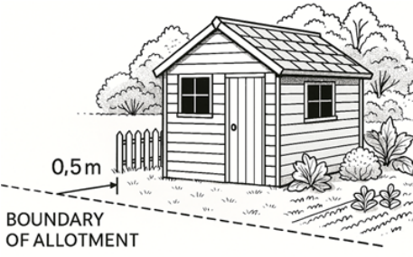 | Location  Minimum of 0.5m away from paths.  Minimum of 1m from roadways;  Site boundary wherever possible.

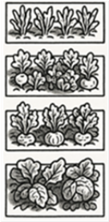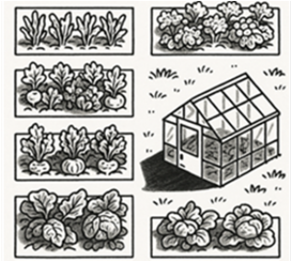 | All structures must be sited to cast the least amount of shade on neighbouring plots.

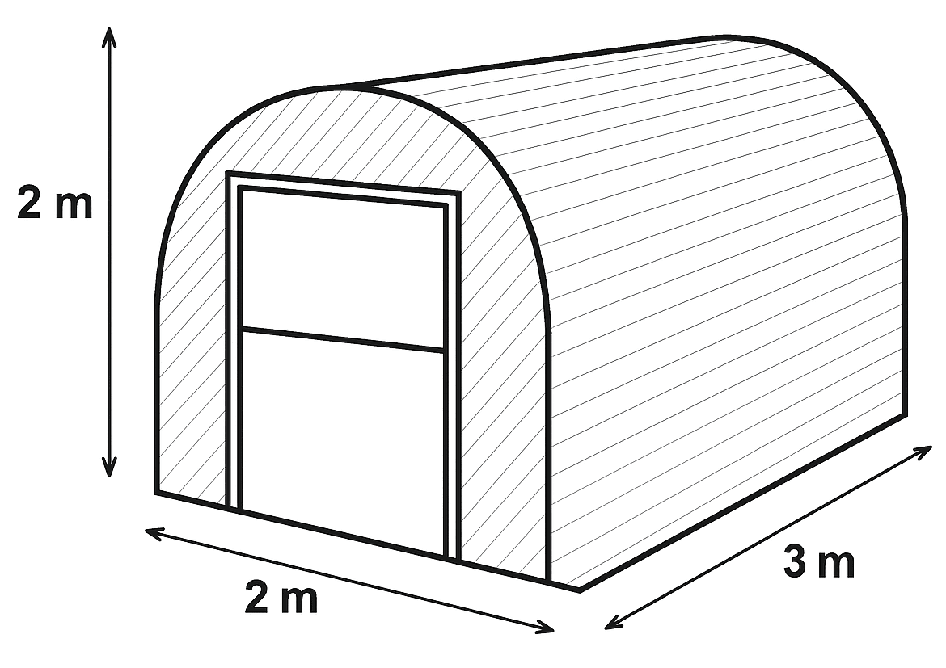 | Polytunnel  Recommended Size  Length: 3m (10ft)  Width: 2m (6.5ft)  Height: 2m (6.5ft)

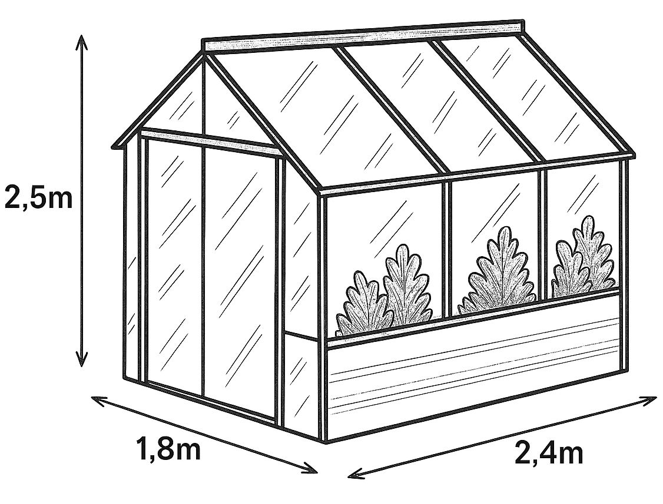 | Greenhouse and Shed  Maximum Size  Length: 2.4m (8ft)  Width: 1.8m (6ft)  Height: 2.5m (approximately 8ft) | 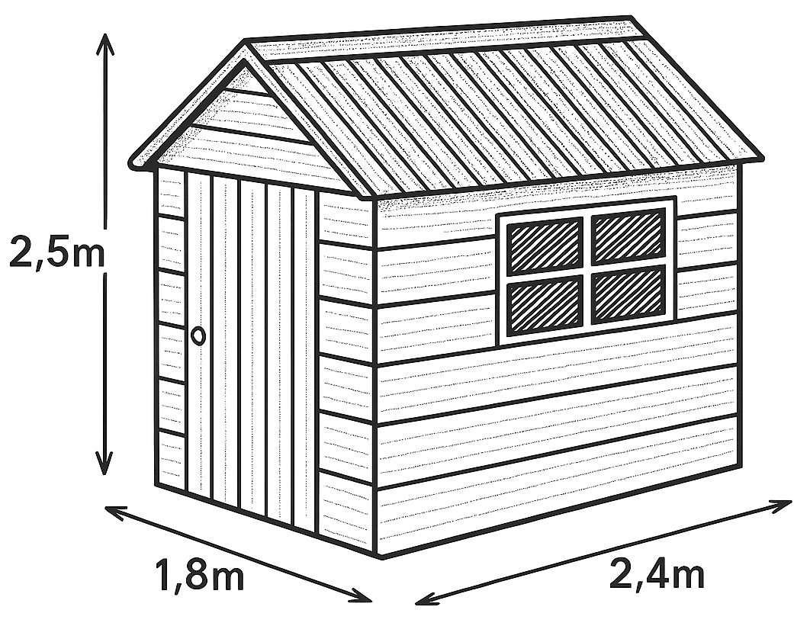

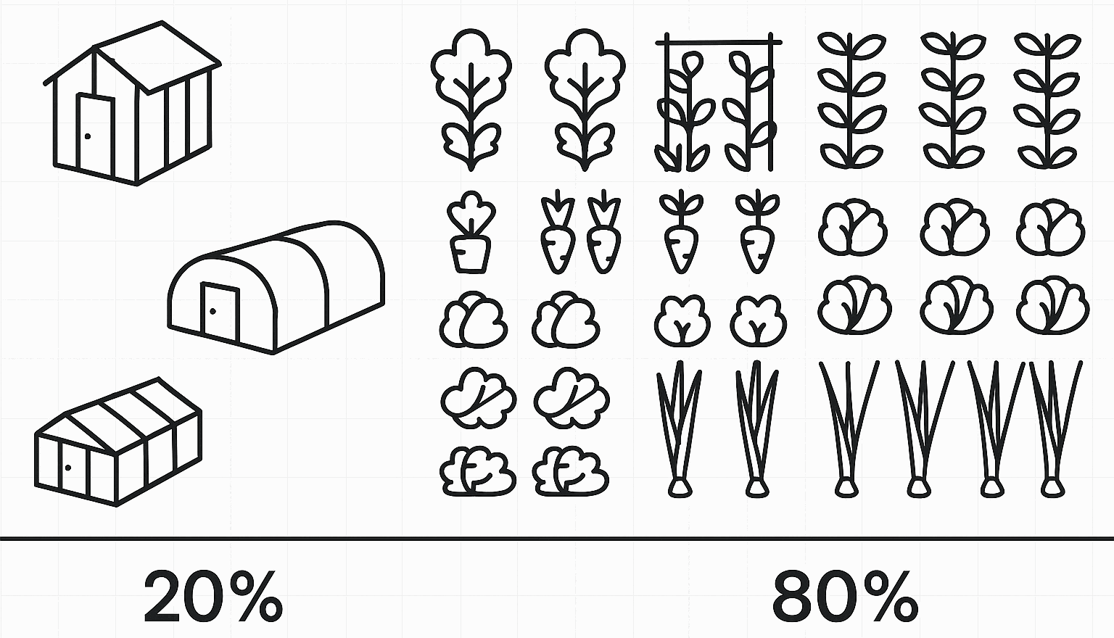 | Area  Floor Area of all structures must not exceed 20% on the plot.  Only one shed, polytunnel or greenhouse per plot.

